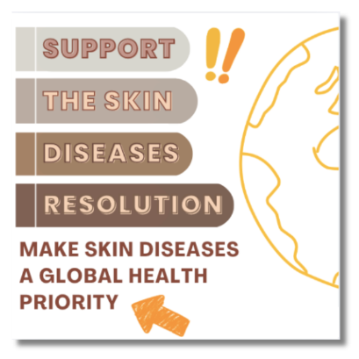
SOCIAL MEDIA POSTS ABOUT SKIN DISEASES RESOLUTION
Below are suggested social media posts.
Tag your Minister of Health where appropriate

General Awareness
🌍 Skin health affects us all! Over 2 billion people worldwide live with skin diseases and conditions, which can cause pain, stigma, and economic challenges. It's time to prioritize skin health globally.
✊ Join the call for action! We urge our Minister of Health (@name) to support the Resolution for Skin Diseases at the 2025 World Health Assembly.
👉 Use #SkinDiseasesResolution to spread the word! Learn more here: https://globalskin.org/WHAResolution

Longer version:
🌍 Skin health is global health. Over 2 billion people worldwide live with skin conditions, facing not only physical discomfort but also stigma, mental health challenges, and financial strain.
From high-income countries managing inflammatory diseases to low-income regions battling infectious skin conditions, the impact is universal—but access to care isn’t.
🩺 The solution? An integrated global approach to skin health. By prioritizing research, increasing access to care, and addressing stigma, we can create lasting change.
📢 Let’s take action together! We urge our Minister of Health (@name) to support the Resolution for Skin Diseases at the 2025 World Health Assembly.
💡 Join the movement and spread the word: https://globalskin.org/WHAResolution #SkinDiseasesResolution #SkinHealthForAll #GlobalHealth​.

Mental Health & Stigma
💔 Did you know? Skin diseases don’t just affect the body—they deeply impact mental health, leading to anxiety, depression, and even social isolation.
🌟 Let's change the narrative. Everyone deserves dignity, support, and access to affordable care.
📢 Take action now! Contact your Minister of Health to support the Resolution for Skin Diseases. https://globalskin.org/WHAResolution
💬 #SkinDiseasesResolution

🌍 Skin conditions affect everyone, everywhere. Inflammatory conditions like psoriasis, eczema, and acne impact millions, leading to stigma, mental health struggles, and reduced quality of life.
🩺 Access to care and awareness are still challenges. It’s time to make skin health a global priority.
📢 Take action! Contact your policymakers to support the Resolution for Skin Diseases at the 2025 World Health Assembly. https://globalskin.org/WHAResolution
💬 Join the conversation: #SkinDiseasesResolution

Equity & Access
🚨 Access to dermatologists is limited in low-income countries. Many regions face severe shortages of specialists, leaving communities with little to no access to essential skin health care.
🤝 Through increased training about skin conditions for primary health care workers these communities will access faster diagnosis and treatment.
📢 We urge our Minister of Health to support the Resolution for Skin Diseases.
🔗 Join the movement: https://globalskin.org/WHAResolution #SkinDiseasesResolution
🚨 Access to dermatologists is challenging in many high-income countries. Getting an appointment to see a specialist can take months, this shortage of specialists leaves many facing a long time to diagnosis and treatment.
🤝 Together, we can bridge this gap through global action.
📢 We urge our Minister of Health to support the Resolution for Skin Diseases.
🔗 Join the movement: https://globalskin.org/WHAResolution #SkinDiseasesResolution

Climate Change & Skin Health
🌍 Climate change impacts skin health. Rising temperatures, more sunny days and pollution increase skin diseases worldwide, especially in vulnerable communities.
⚡ The solution? Policies that integrate skin health into climate change strategies.
📣 Act now! Contact your policymakers to support the Resolution for Skin Diseases.
🌟 Spread awareness with #SkinDiseasesResolution

Economic & Social Impact
💸 Skin diseases cost millions in lost productivity and healthcare. Families are forced to choose between treatment and daily needs.
🛑 This must stop.
📢 Support change today! Urge your policymakers to prioritize skin health at the 2025 World Health Assembly.
🗨️ Together, we can make a difference https://globalskin.org/WHAResolution #SkinDiseasesResolution

