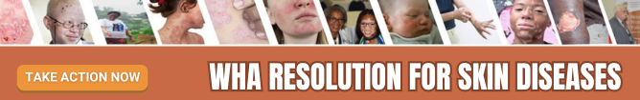

WEBSITE /NEWSLETTER TEXT
Support the WHA 2025 Resolution on Skin Diseases!
Skin diseases affect over 4.69 billion people globally, making them one of the top 10 causes of disability. From eczema and psoriasis to rare genetic conditions, skin diseases have devastating impacts on individuals’ health, mental well-being, and livelihoods.
The World Health Assembly (WHA) will meet in May 2025 to adopt a groundbreaking resolution to prioritize skin health as a global health issue. This resolution proposes to:
- Establish a WHO Global Action Plan for Skin Diseases.
- Invest in training healthcare providers to diagnose and manage skin diseases effectively.
- Strengthen diagnostic capacity and surveillance for skin diseases.
- Promote multidisciplinary skin diseases research on new diagnostics and affordable treatments and ensure their equitable access.
- Advance research into social and economic impacts of skin diseases.
- Support integrated and holistic action on skin diseases to support patients’ needs including their mental well-being.
- Strengthen healthcare systems and improve health equity.
Join us in advocating for this crucial resolution.
- Share your support on social media using #SkinDiseasesResolution.
- Contact your Minister of Health and urge them to endorse this resolution.
- Learn more about the WHA Resolution for Skin Diseases by visiting https://globalskin.org/WHAResolution
Together, we can build a future where no one is left behind due to skin diseases.

