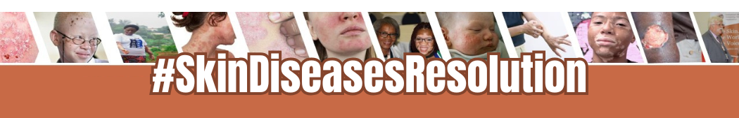
KEY MESSAGES
- Skin Diseases Must be a Global Priority: Skin diseases impact over 4.69 billion people globally and rank among the top 10 causes of disability.
Locally, conditions such as [insert locally relevant conditions] strain healthcare systems and lead to significant socio-economic challenges.

- The Time for Action is Now: Adopting this resolution at WHA 2025 will enable the creation of a comprehensive Global Action Plan, providing a framework for prevention, early detection, research, and integrated care.
- National Leadership Opportunity: [Country] has a unique opportunity to demonstrate its leadership in advancing universal health coverage (UHC) by supporting this resolution. This action highlights [country’s] commitment to addressing health challenges like skin cancer, infections, and rare conditions.
- Call to Collaborate: Join the leading co-sponsors — Côte d’Ivoire, Nigeria, Togo, Micronesia, Ethiopia, China, Egypt, and Colombia — in advocating for this resolution.
PROOF POINTS
- Addressing Stigma and Mental Health: The visible nature of skin diseases often leads to stigma, discrimination, and psychosocial distress. People living with skin conditions frequently face anxiety, depression, and isolation. Combating stigma is essential for promoting mental health and dignity for those affected.
- Capacity Building to Improve Diagnosis and Treatment: Many individuals with skin diseases face delays in diagnosis due to a lack of trained healthcare professionals and limited access to healthcare facilities. High costs for treatments, especially in low-resource settings, exacerbate inequities. Expanding expertise, particularly among primary health care workers, will improve access to timely, affordable care and essential medicines which is crucial to reducing the global burden.
- Reducing Economic Impacts: Skin diseases contribute to loss of productivity, increased healthcare costs, and socio-economic inequality. Investing in skin health yields economic benefits.
- Skin Health Equity is Essential: Vulnerable groups, including women, children, and underserved communities, face the greatest burden of skin diseases. Addressing these disparities is key to achieving the United Nations’ Sustainable Development Goal 3 in relation to health equity.
- Climate Change and Skin Health: Climate-related factors, including UV exposure, pollution, and rising temperatures, exacerbate the incidence and severity of skin diseases, especially in low-resource settings​. Policymakers must integrate climate resilience into health systems to address these evolving challenges effectively.

